**ASSIGNMENT-5**

**1. Questions:**

i. Creating a table STUDENT with following information: Name of table: STUDENT, columns and data types: rollno number(6), name varchar(20), branch varchar(20);

**Query:**

create table Student (

rollno number(6),

name varchar(20),

branch varchar(20)

);

**Output:**

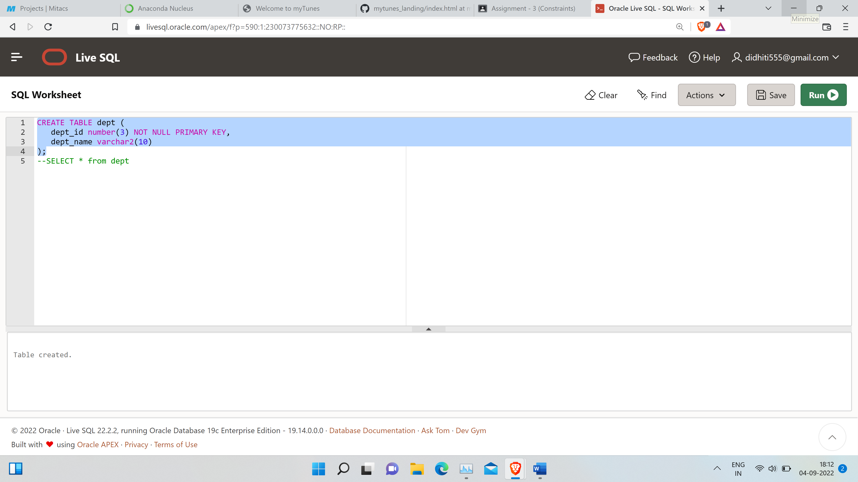

ii. Inserting data into the student table

**Query:**

insert into Student(rollno, name, branch)values(40,'Raj','CSE');

insert into Student(rollno, name, branch)values(50,'Ram','IT');

insert into Student(rollno, name, branch)values(60,'Rahul','CSE');

insert into Student(rollno, name, branch)values(10,'Joe','EEE');

insert into Student(rollno, name, branch)values(20,'Joy','ECE');

**Output:**

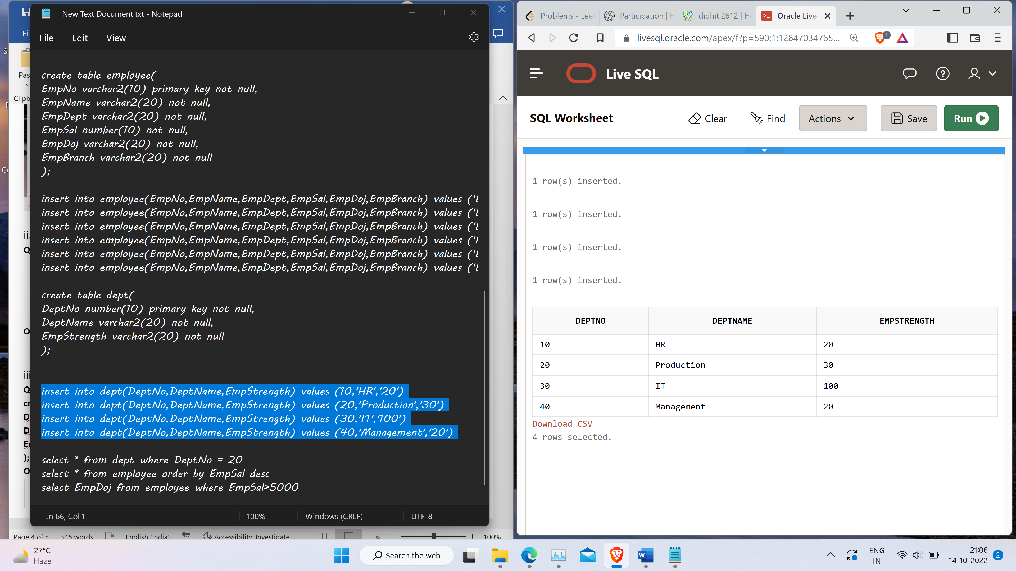



iii. Altering table by adding new column class varchar(20)

**Query:**

alter table student

add class varchar2(20)

**Output:**

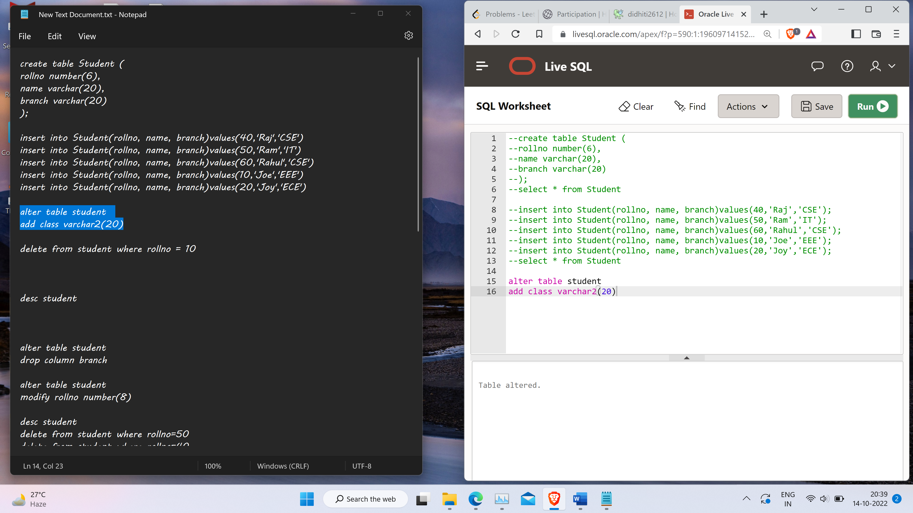

iv. Deleting a row from the table

**Query:**

delete from student where rollno = 10

**Output:**

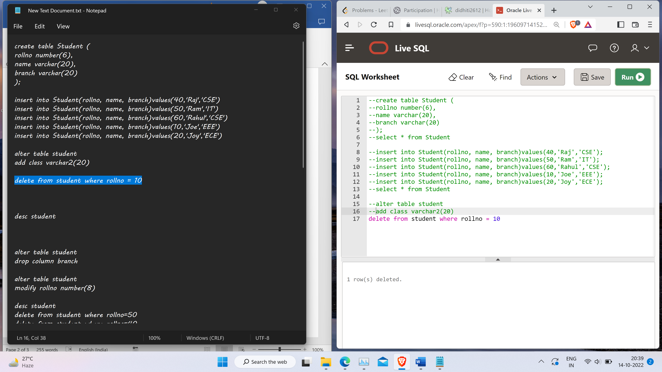

v. Drop column branch

**Query:**

alter table student

drop column branch

**Output:**

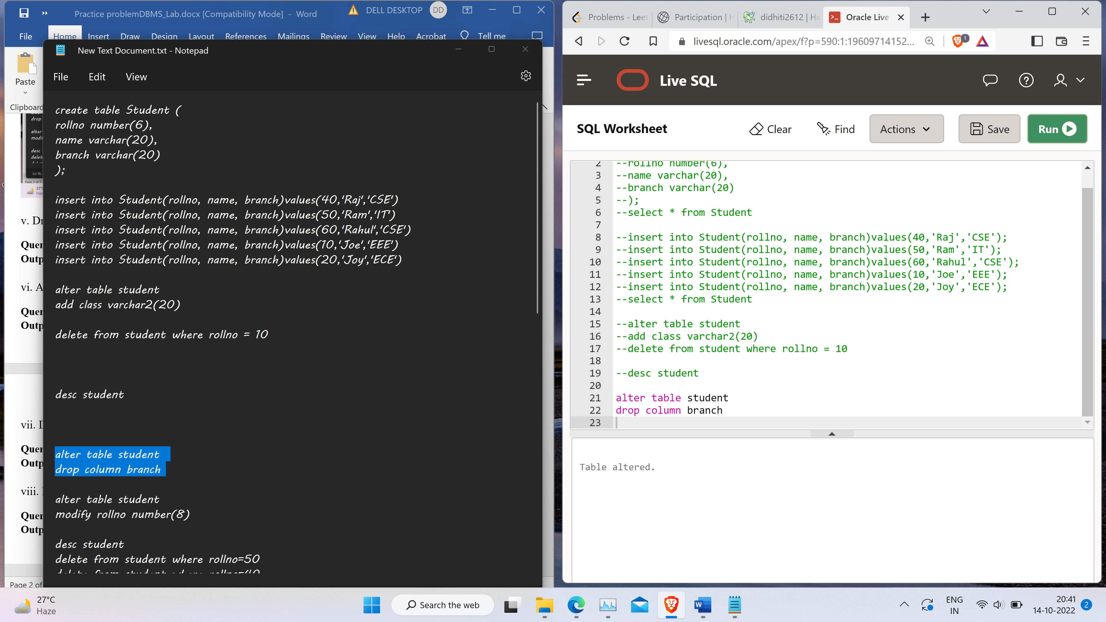

vi. Alter table by changing the data type of rollno to number(8).

**Query:**

alter table student

modify rollno number(8)

**Output:**



vii. Delete all the data from student table.

**Query:**

delete from student where rollno=50;

delete from student where rollno=40;

delete from student where rollno=60;

delete from student where rollno=20;

**Output:**

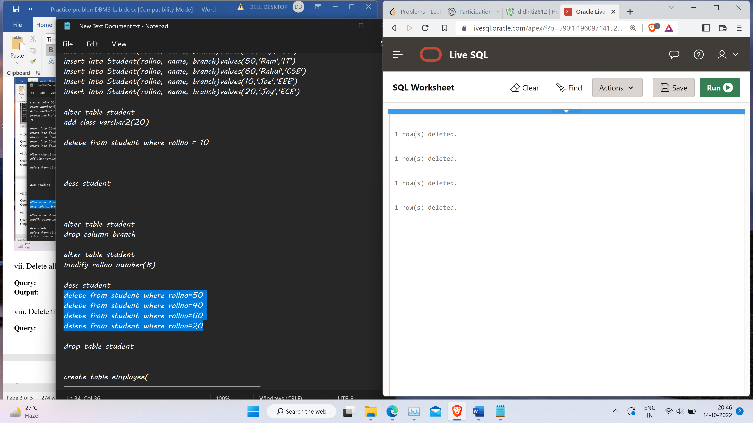

viii. Delete the table.

**Query:**

drop table student

**Output:**

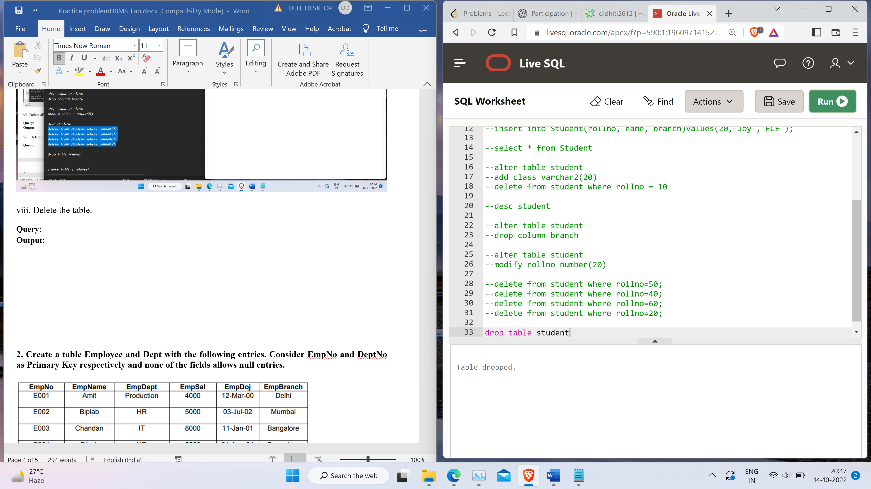

**2.** **Create a table Employee and Dept with the following entries. Consider EmpNo and DeptNo as Primary Key respectively and none of the fields allows null entries.**

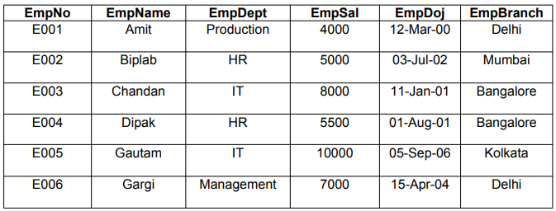

|  |  |  |
| --- | --- | --- |
| **DeptNo** | **DeptName** | **EmpStrength** |
| 10 | HR | 20 |
| 20 | IT | 30 |
| 30 | Production | 100 |
| 40 | Management | 20 |

i.   Display the records of **emp** table.

**Query:**

insert into employee(EmpNo,EmpName,EmpDept,EmpSal,EmpDoj,EmpBranch) values ('E001','Amit','Production',4000,'12-Mar-00','Delhi');

insert into employee(EmpNo,EmpName,EmpDept,EmpSal,EmpDoj,EmpBranch) values ('E002','Biplab','HR',5000,'12-Mar-00','Mumbai');

insert into employee(EmpNo,EmpName,EmpDept,EmpSal,EmpDoj,EmpBranch) values ('E003','Chandan','IT',8000,'12-Mar-00','Bangalore');

insert into employee(EmpNo,EmpName,EmpDept,EmpSal,EmpDoj,EmpBranch) values ('E004','Dipak','HR',5500,'12-Mar-00','Bangalore');

insert into employee(EmpNo,EmpName,EmpDept,EmpSal,EmpDoj,EmpBranch) values ('E005','Gautam','IT',10000,'12-Mar-00','Kolkata');

insert into employee(EmpNo,EmpName,EmpDept,EmpSal,EmpDoj,EmpBranch) values ('E006','Gargi','Management',7000,'12-Mar-00','Delhi');

select * from Employee

**Output:**

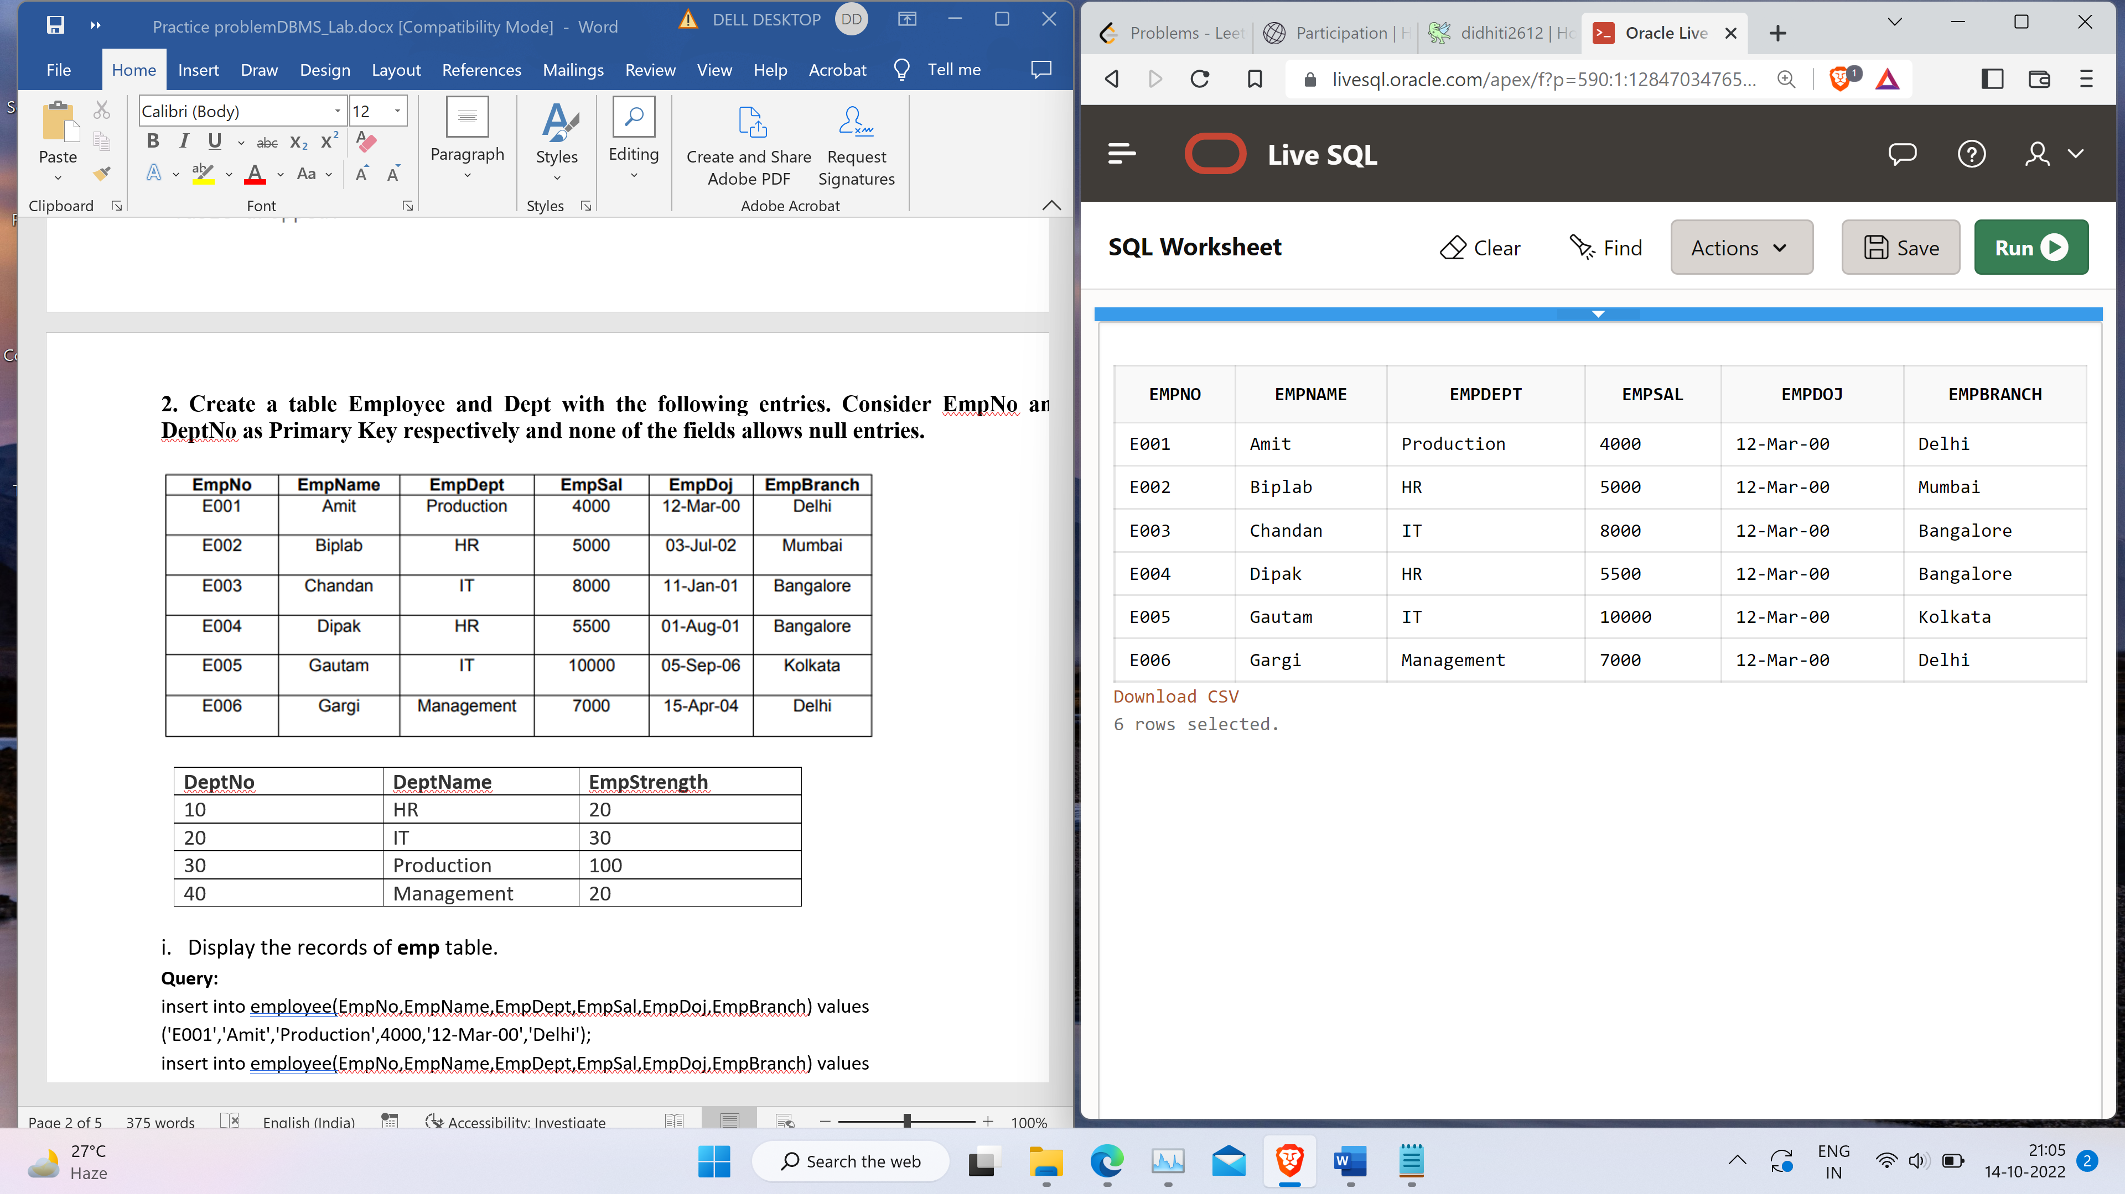

ii.  Display the records of **dept** table.

**Query:**

insert into dept(DeptNo,DeptName,EmpStrength) values (10,'HR','20');

insert into dept(DeptNo,DeptName,EmpStrength) values (20,'Production','30');

insert into dept(DeptNo,DeptName,EmpStrength) values (30,'IT','100');

insert into dept(DeptNo,DeptName,EmpStrength) values (40,'Management','20');

select * from dept

**Output:**



iii. Display the records of **emp** table who are working in department 20.

**Query:**

select * from dept where DeptNo = 20

**Output:**

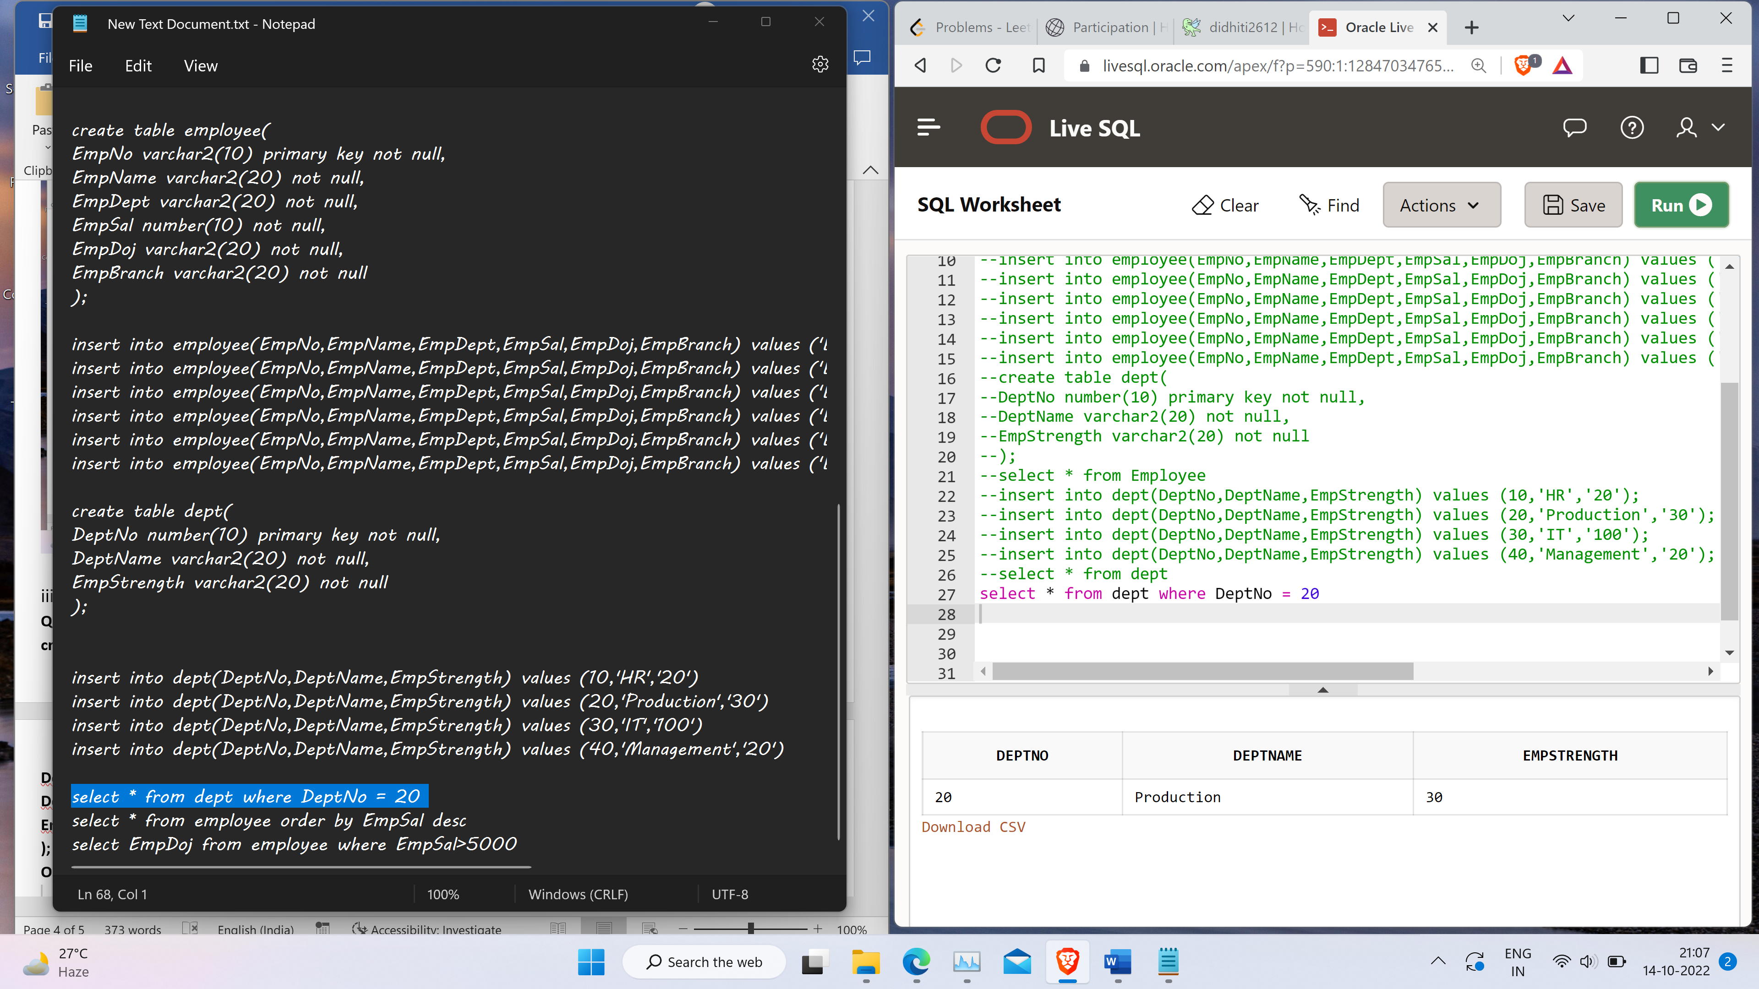

iv.  Display the records of **emp** table in descending order of the salary.

**Query:**

select * from employee order by EmpSal desc

**Output:**

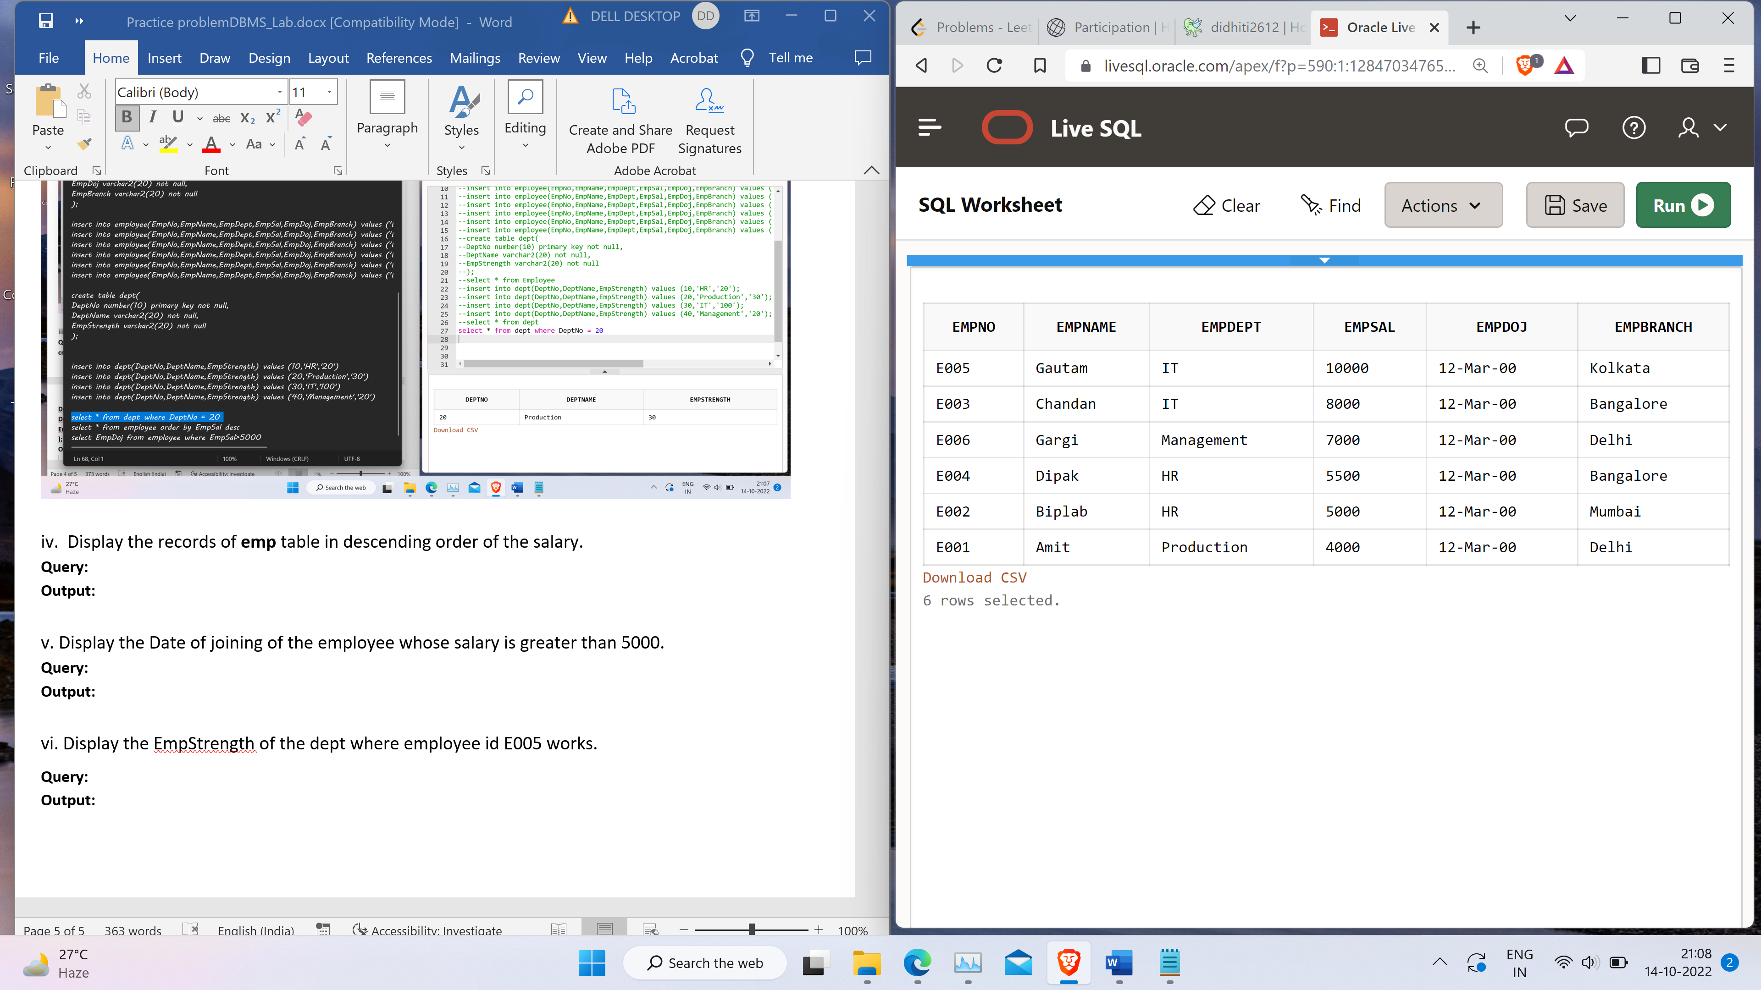

v. Display the Date of joining of the employee whose salary is greater than 5000.

**Query:**

select EmpDoj from employee where EmpSal>5000

**Output:**

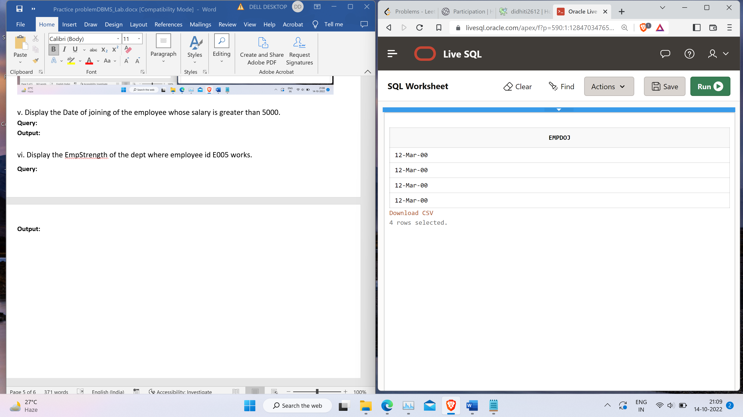

vi. Display the EmpStrength of the dept where employee id E005 works.

**Query:**

select dept.EmpStrength from dept,Employee

where dept.DeptName=Employee.EmpDept AND Employee.EmpNo='E005';

**Output:**

